

Trade Bust For CAB Order
PITS 40728 & SEDL 9059
Test Plan

Ellen Lowery, Ext. 7173

Table of Contents
Problem Description – SEDL 8867 3
Resolution 3
Test Case 1 – Trade bust for CAB order filled at OMT 3

Problem Description – SEDL 9059
Trade bust failed on CAB order filled at OMT due to the obsolete information on the orders at TE.

Resolution
Query the OHS for busing order traded manually at OMT before busting the tradables.

Test Case 1 – Original Order Cancellation at TE

Test Procedure:
Set Routing Property: Set Crowd Default Destination for your class.
Enter a quote: 0.00 – 0.05 X 100
Enter an order: Check the CAB for an order, Buy 100@MKT, Origin: C & Contingency: None
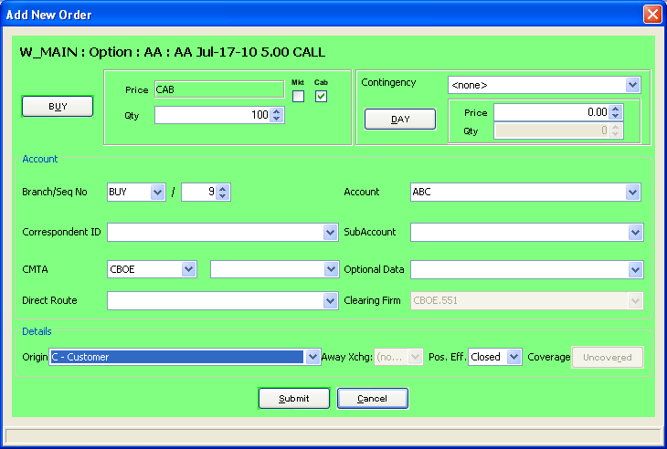
Verification:
Verify that Order is routed to your Crowd OMT as follows:
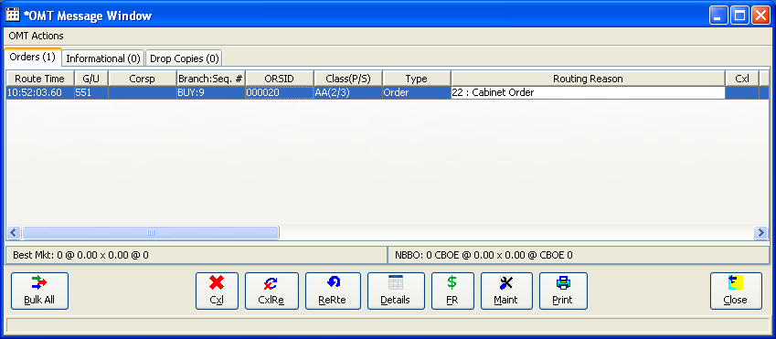

Manually fill the order at the OMT: From the Trader GUI OMT Message window, manually fill the above order.
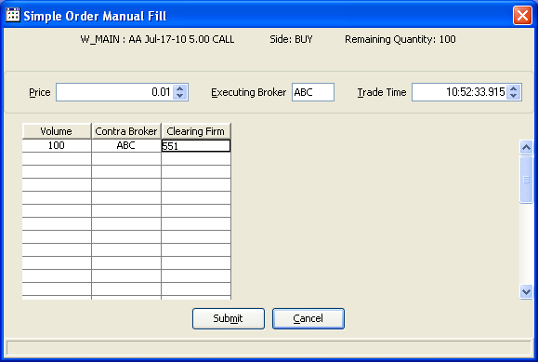

Verifications: Verify that order is filled from the Status Widow.
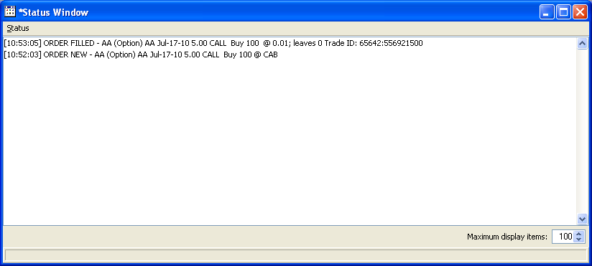

Bust trade: Login SAGUI and open the Trade Query New Windonw. Query the order by the User or Trade ID above. Busting order should be successful as bvelow:

